CSD-325 Module 3 Assignment

Name: Reed Bunnell

Assignment: Module 3 - Cho-Han Flowchart and Code Changes

# Flowchart Overview

The following flowchart illustrates the execution flow of the Cho-Han game program. It includes all major decision points such as bet validation, dice rolling, bonus logic for totals of 2 or 7, win/loss determination, and purse updates.

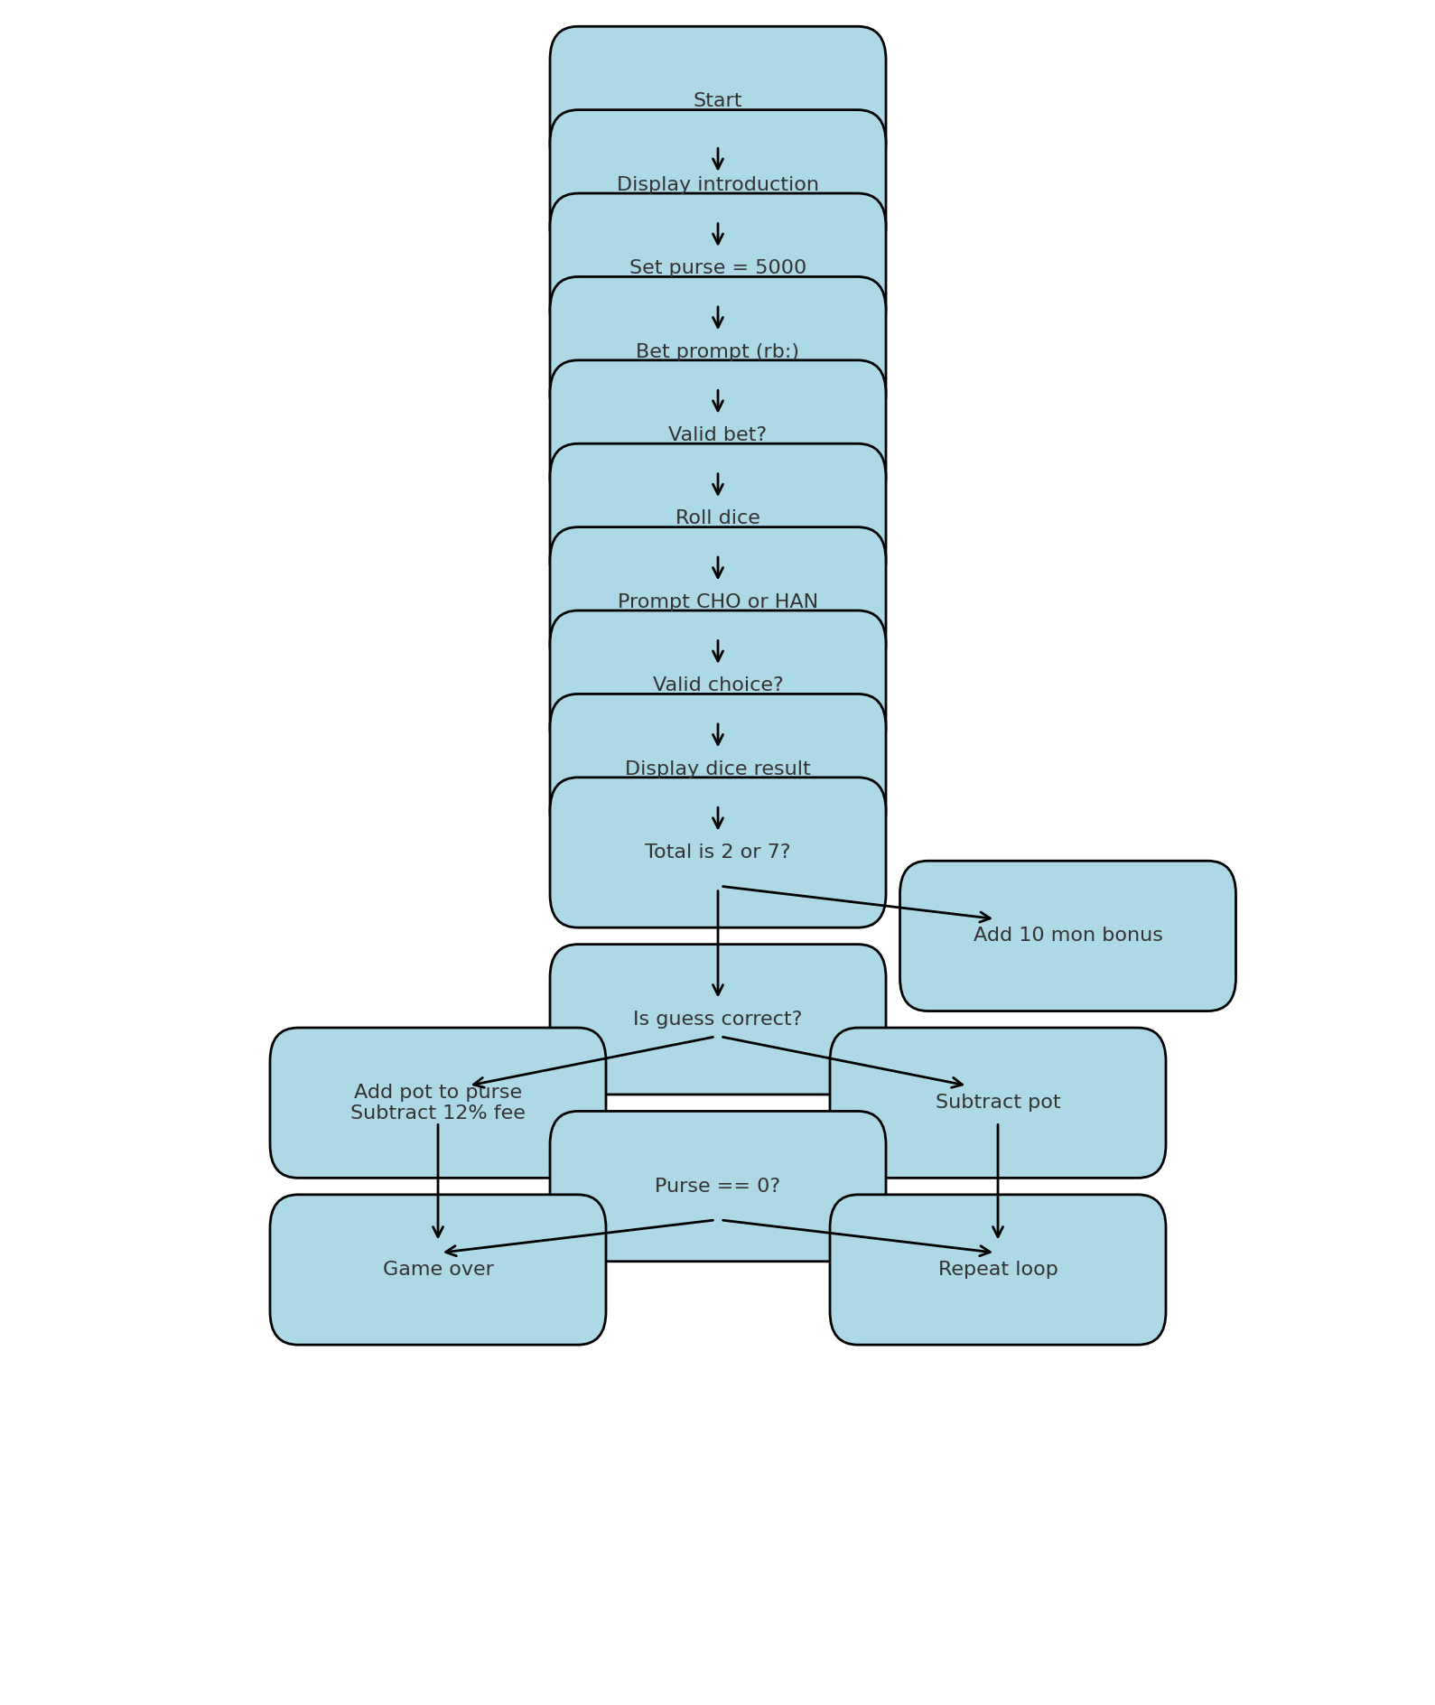

# Summary of Code Modifications

- Updated all input prompts to use "rb:" instead of ">".

- Increased the house fee from 10% to 12%.

- Added a bonus of 10 mon if the dice roll totals to 2 or 7.

- Displayed a message to the player if they receive the bonus.

- Updated the introductory text to explain the bonus rule.

- Saved the modified code as "chohan_rb.py".